ACL Repair Rehabilitation
Phase 2 (~Weeks 2-6)

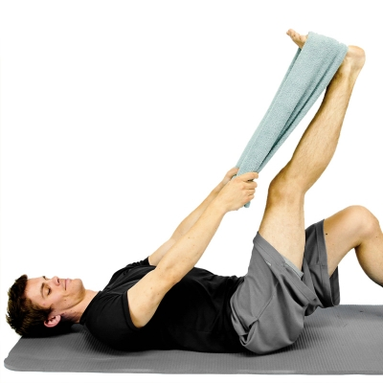
HAMSTRING STRETCH WITH TOWEL While lying down on your back, hook a towel or strap under your foot and draw up your leg until a stretch is felt along the backside of your leg. Keep your knee in a straightened position during the stretch. **At least twice per day, 3 is the goal** Repeat 5 Times Hold 10 Seconds Complete 1 Set Perform 3 Times a Day

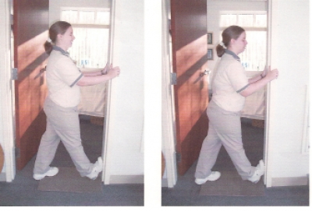
CALF DOORWAY STRETCH Place bottom of foot in doorway. To increase stretch lean body forward. At least twice per day, aiming for 3.
Repeat 5 Times Hold 10 Seconds Complete 1 Set Perform 3 Times a Day

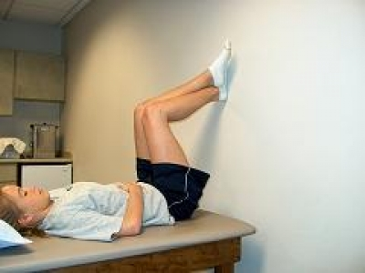
WALL SLIDES Lie on your back with your buttocks about 1 foot away from the wall as pictured. Using your uninvolved foot to assist, slide your involved foot down the wall as tolerated. Use uninvolved leg to slide involved leg back up the wall.
Repeat 5 Times Hold 15 Seconds Complete 1 Set Perform 1 Times a Day

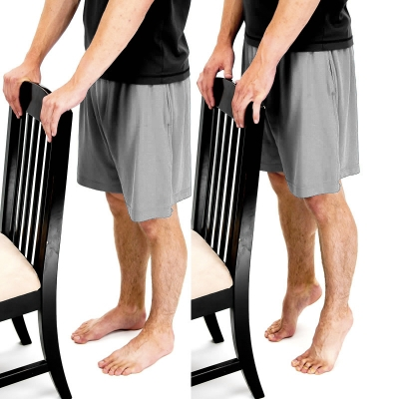
STANDING HEEL RAISES While standing, raise up on your toes as you lift your heels off the ground.
Repeat 15 Times Hold 5 Seconds Complete 1 Set Perform 3 Times a Week

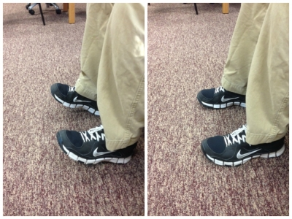
STANDING DORSIFLEXION Start with your feet on the ground. Next, raise up both forefeet and toes as shown as you bend at your ankle. Keep your heels on the ground the entire time.
Repeat 15 Times Hold 5 Seconds Complete 1 Set Perform 3 Times a Week

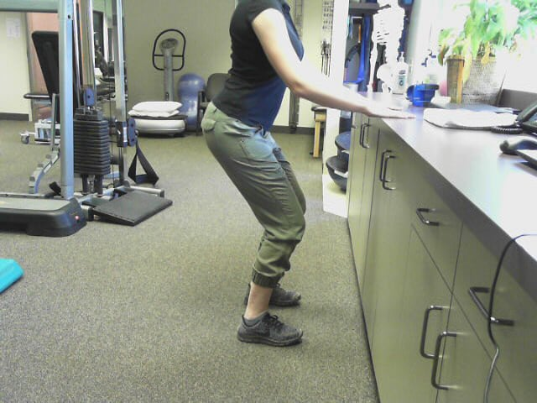
MINI SQUAT AT COUNTER Standing with feet shoulder length apart, bend knees slightly and return to standing position. Don't let knees go over toes and keep hands lightly on counter top for support.
Repeat 10 Times Hold 5 Seconds Complete 1 Set Perform 1 Times a Day

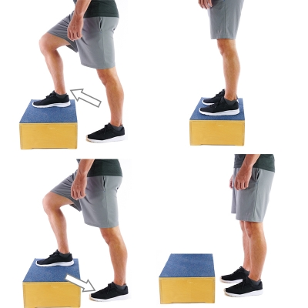
STEP UP AND STEP DOWN - IPSILATERAL (SAME SIDE) Start by standing in front of a step/step stool with both feet on the floor. Step forward and up the step with your target leg and use that leg to lift your body weight up onto the step with the other leg. Once both feet are on the step, step back down backward with the other leg first so that your target leg does the work to lower your body back down to the ground. Then return the target leg to the floor next to your other leg. You may need something to hold on to for balance support. Repeat this on the same side.
Repeat 10 Times Hold 1 Second Complete 1 Set Perform 1 Times a Day

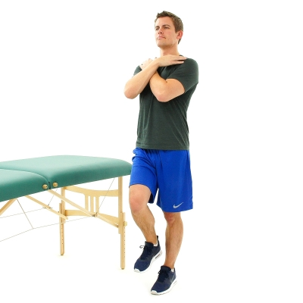
RHOMBERG STANCE - SINGLE LEG - SLS Cross your arms over your chest and then stand on one leg. Perform this next to a table or other sturdy object. Hold your balance in this position. If you lose your balance, you can use one or more strategies to help: Touch your toes down Take a step Unfold your arms and raise them to the sides Grab on to something for support Duration 10 Seconds Complete 5 Sets Perform 1 Times a Day

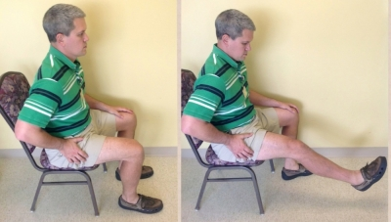
SEATED KNEE EXTENSION, LAQ Sit at edge of chair, table or plynth table. Lift foot of involved leg off the floor, feeling quad muscle tighten up. It is ok if you knee does not completely straighten out at first, as long as you feel the muscle working.
Repeat 10 Times Hold 5 Seconds Complete 1 Set Perform 1 Times a Day

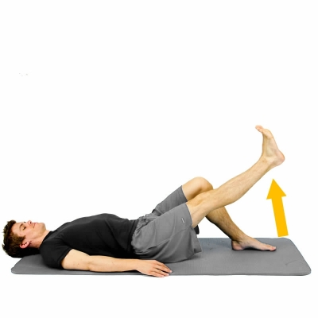
STRAIGHT LEG RAISE - SLR While lying on your back, push your back into the bed/floor then raise up your leg with a straight knee. Keep the opposite knee bent with the foot planted on the ground.
Repeat 10 Times Hold 5 Seconds Complete 1 Set Perform 3 Times a Week

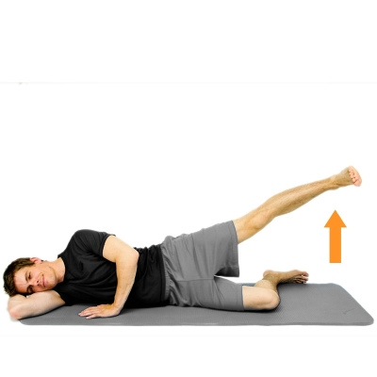
HIP ABDUCTION - SIDELYING While lying on your side, slowly raise up your top leg to the side. Keep your knee straight and maintain your toes pointed forward the entire time. Keep your leg in-line with your body. The bottom leg can be bent to stabilize your body.
Repeat 10 Times Hold 5 Seconds Complete 1 Set Perform 1 Times a Day

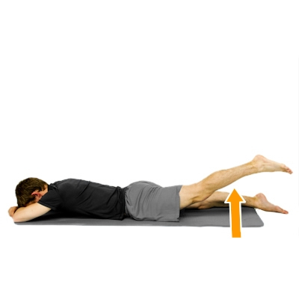
PRONE HIP EXTENSION While lying face down with your knee straight, slowly raise up leg off the ground. Maintain a straight knee the entire time.
Repeat 10 Times Hold 5 Seconds Complete 1 Set Perform 1 Times a Day

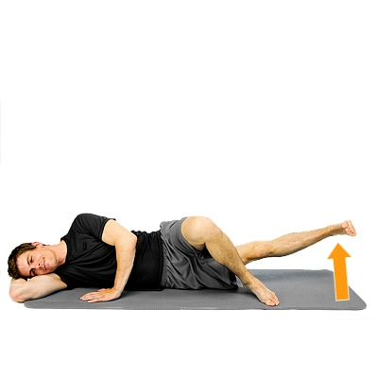
HIP ADDUCTION - SIDELYING While lying on your side, slowly raise up your bottom leg towards the ceiling. Keep your knee straight the entire time. Your top leg should be bent at the knee and your foot planted on the ground supporting your body.
Repeat 10 Times Hold 5 Seconds Complete 1 Set Perform 1 Times a Day

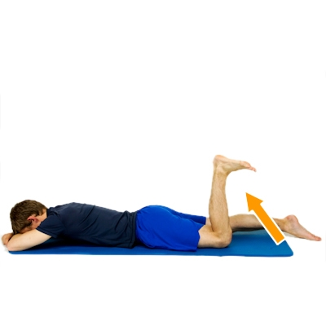
PRONE HAMSTRING CURLS While lying face down, slowly bend your knee as you bring your foot towards your buttock.
Repeat 10 Times Hold 5 Seconds Complete 1 Set Perform 1 Times a Day

